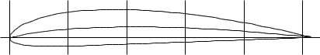

Name = CLARK Y AIRFOIL

Chord[PoweredbyTCPDF](http://www.tcpdf.org)=51[(www](http://www.tcpdf.org).[tcpdf](http://www.tcpdf.org)42136mm[.org)](http://www.tcpdf.org) Radius = 0mm Thickness = 100% Origin = 0% Pitch = 0°